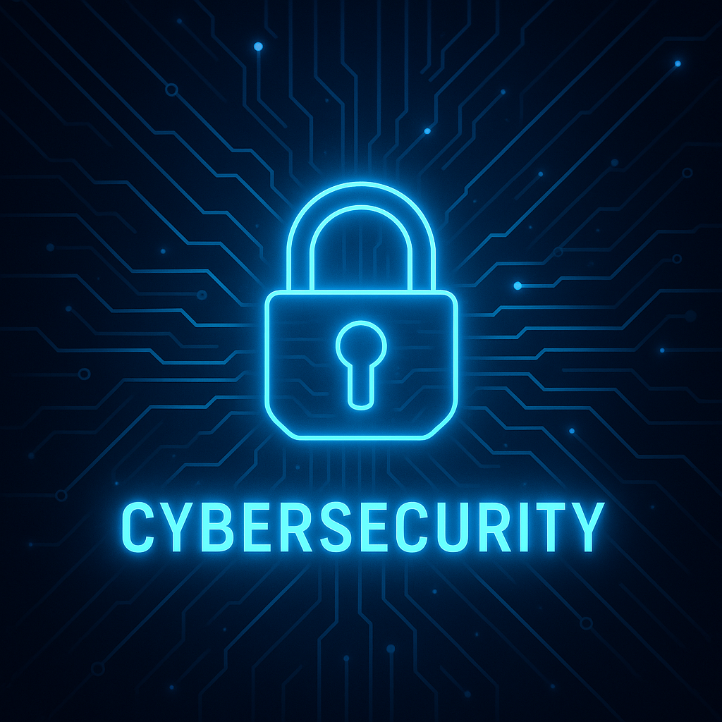

*(Al Jaderi, Z. (2025). Cybersecurity illustration generated using ChatGPT. Unpublished image)*

**Project 8**

**Cybersecurity in Telemedicine  
*Securing Remote Access, Data Protection and Awareness Training***

Name: Zaid Al Jaderi  
 Startup Date: 12 May 2025  
 Project Number: 8

***Noroff Institute of Technology and Digital Media***

**Table of Contents**

Index

1. Introduction  
    1.1 Background and Context  
    1.2 Project Scope and Objectives  
    1.3 Methodology and Approach  
    1.4 Expected Challenges and Assumptions  
    1.5 Structure of the Report
2. Main  
    2.1 Vulnerability Assessment  
    2.2 Remote Access Security  
    2.3 Network Segmentation and Monitoring  
    2.4 User Training and Awareness  
    2.5 Compliance and Legal Considerations
3. Practical Implementation (Proof of Concept)  
    3.1 Testing Results and Screenshots
4. Summary and Conclusion
5. References

**1. Introduction**

**1.1 Background and Context**

Its becoming more common that telemedicine is used in healthcare, it has made it easier for doctors to talk and meet different patients by using digital tools like online video. This approach was very useful during covid-19, but what to keep in mind is that, it creates more and new cybersecurity risks and threats. Due to that healthcare information is very valuable, many hackers target these systems to get the information, its more common now and these events accure more often.

There are much information och details in healthcare that needs or must be protected, information like person information, contact details, names and much more are very sensitive, and thats why cyberscurity can deal with these risks and proctect it so it does not leak out to hackers. If hackers can reach in and steal the information data, it will be very problematic for both the company and the patients. Europé and US have laws like HIPAA and GDPR, these laws tell every orginazation that they must protect peoples information, like personal or health-realated data.

By looking at HIPAA Journal (2024), they show that in 2023, it was reported that 725 data breaches happend in the healtcare sector. By these breaches, over 133 million record of patients where exposed. Also if we look at IBM (2024), it shows that the average cost of data breach scaled up to 10.93 million. That made the healtcare sector the most expensive industry 13th year in a row.

With this information, we can cleary see that telemedicine companies must and also needs strong security. If healtcare companies do not prioritize their security and protect their systems, they fall in the risk to lose both patient trust, legal compliance, by doing that, they risk to lose much money.

**1.2 Project Scope and Objectives**

This project aims to improve the cybersecurity of a growing telemedicine company. Since these companies handle sensitive patient data and rely on remote systems, strong protection is essential. The project focuses on finding weaknesses in the IT environment and securing remote access for doctors and staff. It also includes setting up monitoring tools to detect attacks, training employees to avoid phishing, and ensuring compliance with laws like HIPAA and GDPR.

**1.3 Methodology and Approach**

A virtual lab was created using VMware, including two Windows Servers, a Windows 10 client, and a Kali Linux machine. Server1 handled Active Directory and DNS, while Server2 managed applications, RDP, and VPN. The client was joined to the domain, and Kali was used for simulated attacks. Key steps included setting up the domain, configuring Tailscale VPN, enabling Duo MFA, creating firewall rules, running phishing tests with Gophish, and scanning the network using Nmap. All steps were tested and documented with screenshots.

**1.4 Expected Challenges and Assumptions**

Some expected challenges were setting up Duo MFA with Windows login, configuring the virtual network in VMware, and checking if Windows tools could detect attacks. Running phishing simulations without an email server also required adjustments. The project assumed that employees had basic IT skills, full admin access was available, and simulated attacks could be safely run in the virtual environment.

**1.5 Structure of the Report**

The report is divided into five parts: the main section explains the work and decisions made; the technical section shows configurations and screenshots; the summary presents results and reflections; the references list sources in Harvard style; and the appendix includes extra material if needed.

**2. Main**

**2.1 Vulnerability Assessment**

The systems in telemedicine have been challanged much more these days in cyberscurity problems, due to the use of remote access and the tools online for work. The system they use store patient information, and these system also use different services like VPNs, different cloud systems and also remote desktops. By using these system, you need to have security, if these tools is set up in a wrong way or by any chance let open, they will become very easy target for different hackers to attack these systems and store private information.

Cyberattacks are more common then before in the healthcare enviorment, hackers use different ways to take information, they use phishing and ransomware to attack and take advantage to systems that is not protected. This happen often in telemedicine because its not always the first priority, to protect the systems. According to FidelisSecurity (2025), ”Phishing attacks are the most common causes of data breaches not just in healthcare but almost in every industry.”

By using Kali Linux machine, a network scan was used with a command in Linux which is called Nmap, this identify potential secuirty issues and testing it to know if there is any. The scan showed different open services, for exampel Remote Desktop Protocol (RDP) which were running on server2.

Its common that RDP is a easy target for attackers, thats why it needs to be properly secured. RDP is also used quite common for remote access. If there is not a secure and strong authentication is in use, such as multi-factor authentication, these services will be very vurneable.

By using these tools to scan, it showed that some services was easy to reach due to lack of enough protection. By solving it, different firewall rules were created and added to block outsiders from accessing the system. Also, a multi-factor authentiocation was created and set up to make it easier to log in, in a much more safer way when logging in remote.

To see how easy it is to trick users, I tested a phishing attack using a tool called Gophish. I created a fake email that looked like a real message and sent it to a test user in the network. The user opened the email and clicked the link. This showed that users can be tricked into clicking unsafe links if they are not trained to spot fake messages. This kind of social engineering is a big problem, especially when people work from home or connect to systems remotely.

Phishing is still one of the most common ways hackers break into systems. In healthcare, it is very dangerous because patient data is sensitive and must be protected. The HIPAA Journal (2024), says that over 133 million healthcare records were exposed in 2023, and many of these cases started from phishing emails or mistakes made by users.

This test shows that protecting systems is not only about firewalls or passwords—it also means training the people who use the systems. Users need to know how to recognize fake emails and what to do when something looks suspicious. Along with that, systems should have strong login security, regular checks for vulnerabilities, and simple rules that help users stay safe.

Without these protections, telemedicine companies stay open to cyberattacks, and that can lead to big problems like data loss, service shutdowns, or legal issues. This is why user awareness and secure systems must work together.

**2.2 Remote Access Security**

Since staff and sometimes doctors work from their own homes, or simply outside their workplaces, remote access becomes an important part of telemedicine. According to the American Medical Association (2023), ”74.4% of physicians surveyed reported that telehealth was used in their medical practices, nearly three times the share in 2018”. The problem isn’t that they work from home, but rather that issues can arise if, for example, the remote access hasn’t been properly secured. This risk has been reduced because several security measures have been taken and combined in a test environment.

Server1 is the domain, and therefore the Windows 10 client was first connected to the domain, where Active Directory is used and running. With that in place, it became more possible to manage different central parts, such as user account management or other security policies.

Two different accounts were created – user accounts that would be used – where one was for a doctor and the other for IT administrators. After creating both, they were placed in separate groups, which then received their own access permissions. Through this process, each role could be assigned properly, and everyone was given a certain level of access.

According to Tailscale (2025), ”Some key advantages of the platform include secure and private connections between devices, a flexible network topology, and a streamlined setup”.

So a installation of Tailscale VPN was done on Server2 as well as on the client computer, which is the Windows 10 client. This was done in order to protect the communication between the devices and make it more secure. Through Tailscale, a private tunnel could be created and therefore also an encrypted path between these systems, which helps and protects against various types of eavesdropping.

Because Tailscale VPN was used, the security path was simplified, and there was no need to open any ports in the firewall, which makes it much harder for unauthorized users to attack or even discover different services.

But that level of security was not enough, and an additional installation was made to increase the security — this was done through Duo Multi-Factor Authentication, which is shortened to MFA. This was set up on Server2 to strengthen and extend the security. Through this measure, it was required that users trying to connect via RDP had to approve their own login through their mobile devices. So, even if a password were to be captured or leaked, it would still prevent unauthorized access.

A firewall rule was also created to block the Kali Linux machine, and this was done to further strengthen the protection. This is called network segmentation, which is used to isolate and protect important and highly critical systems from untrusted devices.

The summary is that a VPN, MFA, firewall rules, and domain connection were used to make the systems more secure and create a strong solution for remote access within the field of telemedicine. Through these different actions, the protection of sensitive patient data could be secured from unauthorized users.

**2.3 Network Segmentation and Monitoring**

It is extremely important in all healthcare networks to prevent different attackers from being able to move freely between the healthcare systems, especially if a single computer were to become the target of an attack. This can be protected through network segmentation, which is a method for both communicating and controlling how these different devices can connect to each other or communicate with each other. According to NHS Digital (2023), ”Network segmentation will also greatly increase the difficulty for an attacker to reach their goal once in the network, as their point of entry may not have any means of reaching the target sensitive data or critical asset”. It seems very simple to carry out as a security measure, but it is extremely effective and can make a big difference.

In the test environment, a firewall rule was created on Server2, this rule is adapted and a process for network segmentation. Through this rule, all traffic from the Kali Linux machine and its IP address was blocked. This demonstrated the importance of being able to still stop an attacker from reaching sensitive resources, even if they had already entered the network. When this firewall rule was activated, the Kali machine could no longer scan Server2 using tools and commands in Linux such as Nmap. With this method, it was proven that the firewall was configured correctly and that services on Server2 actually remained protected.

So when looking at network segmentation, it is important to understand that this is useful especially in telemedical environments, since remote access tools and critical systems are used that must be protected, as they also contain sensitive information such as patient data. If, for example, one of the systems were attacked and an attacker got in, the segmentation could significantly limit this threat and also prevent the attacker from spreading into other parts of the network. If a basic firewall is configured correctly, even that method can provide extra protection. Even if one might not think it is much of a protection, it actually is.

Monitoring was also used through built-in Windows tools, such as Event Viewer. This can be used and was used to detect different suspicious activities but also to review system logs. Self-made and created attacks and phishing tests were also carried out, this happened through Kali Linux against Server2. After performing these attacks, several signs of the attacks could be seen, such as failed login attempts, which proves that the system produced relevant security information and events.

There are other advanced systems that can be used for monitoring, such as Snort or SIEM. However, these systems were not used. It turned out that even Windows built-in tools were useful and good to have for detecting threats. This can make it easier for smaller companies to learn to use Windows' own tools, to minimize expensive costs but still raise their security.

This information is summarized with the fact that system monitoring and network segmentation make everything much more secure in a healthcare network. This method makes it extremely difficult for attackers to get into multiple systems and try to move further into the network. This method also gives the IT staff good information to quickly act in such an event and to be able to shut the attackers out.

**2.4 User Training and Awareness**

Many believe that most cyberattacks happen due to technical errors, but that is not the case — it is rather because a human makes a mistake. A global study reported by IBM found that *“Human error was a major contributing cause in 95% of all breaches”* (Cetrom, 2025).

And since humans can make mistakes, it is especially serious in telemedical environments where different types of sensitive information are handled, such as patient information. This makes it more serious because the staff does not always have the knowledge required to recognize these security threats.

The most common method an attacker uses is phishing, which is a method where an email is sent to trick the recipient. Most often, the recipient is asked to click on a link that can be harmful or to give away login information.

With the help of the tool Gophish, a phishing simulation could be carried out, where a fake email was created and sent to a specific user to test the process. The email that was sent always looks legitimate, and it did this time too, in that way it’s possible to find out if the user can be tricked.

With this method, it becomes clear that it is very important for staff to go through user training, because technical security measures alone are not enough in every aspect. Many systems can use VPN, strong passwords, or even firewalls, but this does not rule out breaches, because a single wrong click by a user can lead to serious problems and intrusions.

Through user training, staff become more aware of security threats and learn how to check email addresses, and how they can detect suspicious links that they can avoid clicking on. They also learn how to act in these situations and can report back to the company’s security team.

Such training should be designed in a very simple way for the staff, and it should be repeated regularly for it to stick. Some concrete examples can be showing how phishing attempts may look and how to relate to them. The training can be designed in several different ways and does not have to rely on one method only — it can be everything from posters in the workplace, awareness tests with short quiz questions they can answer, but most of all have digital trainings as often as possible to help the staff remember and also get into the mindset of IT security.

If the company fails to have the right training, it risks that its own employees are the biggest cause of the security risks that may arise, and therefore become the weak link in the company’s security. But if time is spent on proper training, different methods are developed for it, and employees are reminded, then the staff can become the strong line of defense in the company, and thereby a more sustainable security situation.

This must be a central point in healthcare, because in those environments, the data is sensitive and trust is extremely important.

**2.5 Compliance and Legal Considerations**

There are strict laws and regulations that must be followed for companies within the field of telemedicine. These must be followed and not broken in order to protect the safety of patients but also their privacy. If these strict laws and regulations are not followed, it can harm both the patients but also cause extreme setbacks for the company. The two and probably most important regulations that must be followed are GDPR, which stands for “General Data Protection Regulation” and is targeted towards the EU and has its law there, and the other regulation is shortened to HIPAA, which stands for “Health Insurance Portability and Accountability Act” and is targeted in the USA.

According to Securiti (2025*), “Both regulations share the unilateral goals of placing obligations upon organizations to appropriately manage, store, and protect users’ personal data.”*

These regulations explain and describe to the companies how sensitive information should be monitored and collected, but also how it should be shared or stored. But not only that, these regulations also describe what technical measures are required to protect and prevent data breaches in the companies.

In the test environment, their requirements were followed, and this was done by using different security functions that can contribute to the protection and actions that these regulations demand. One example of that was the method and function of Active Directory, which was used to manage different user accounts. Since HIPAA and GDPR, in their regulations, must and require that only authorized people should have access to sensitive information such as patient data and their health problems, each user was placed in the correct group. This was done through Active Directory, such as IT administrators and doctors being placed in the correct group to have the right access and correct permissions. This method of giving correct and proper access depending on the staff’s work tasks is called “RBAC”, which stands for “Role-Based Access Control”. With this method, the risk of unauthorized access to information that should not be available is reduced, and also the risk of accidental permissions being misused or leaked.

Since many staff today work remotely, data should be protected when that occurs. This was done by installing Tailscale VPN. When installing and using Tailscale VPN, an encrypted connection is created between both the server and the client. This is fundamental and goes hand in hand with HIPAA and GDPR regulations, as all data must be protected when sent over the internet, and this reduces the risk of external threats. Through the Tailscale installation and its use, it was ensured that the information shared over the internet could not be stolen during transfer or be intercepted.

Duo MFA, which stands for “Multi-Factor Authentication”, is another very important security function. According to Cisco (2025), *”Duo multi-factor authentication protects your organization's data at every access attempt, from any device, and from any location.”*

This was used to ensure that if a password were stolen by an attacker trying to break in, it would not be enough for the attacker — they could not log in without other verifications, such as a code sent to the user’s mobile device. This method provides more security and an extra layer of protection against intrusion, which can also be critical in systems that handle patients’ health data.

Through built-in tools in Windows, different methods were used to track login attempts, scanning activity, and phishing tests. This was a setup to monitor both the different events that happen and watch them to ensure and detect security threats. Both GDPR and HIPAA have this as a basic part of their regulations, because keeping these logs and reviewing them helps detect attackers at an early stage in different operations, which can result in staff acting quicker and reducing the risk of sensitive data being leaked.

Through Gophish, a phishing simulation was also carried out. This resulted in seeing that users can still be tricked, which can harm the operation and where information may leak out. This underlines why the laws also place demands on both awareness programs and training to prevent these outcomes. Through these trainings and reminders for the staff, they are trained to recognize these attacks and learn how to avoid them, especially those working remotely from home.

Now, this was a small test environment and not designed on a large scale, but it still reflected the security measures and the real demands that are required in healthcare. Companies can reduce attacks from attackers by using encryption, MFA, access controls, and different trainings — which not only help and protect the company from attackers but also ensure that they meet legal requirements.

If legal requirements are not followed, and these strict laws and rules that exist are ignored, this can result in extremely high fines, the company's reputation being crushed, and the trust from patients being lost, which can have serious consequences for telemedicine environments.

**3. Practical Implementation (Proof of Concept)**

3.1 Proof of Concept / Testing Results

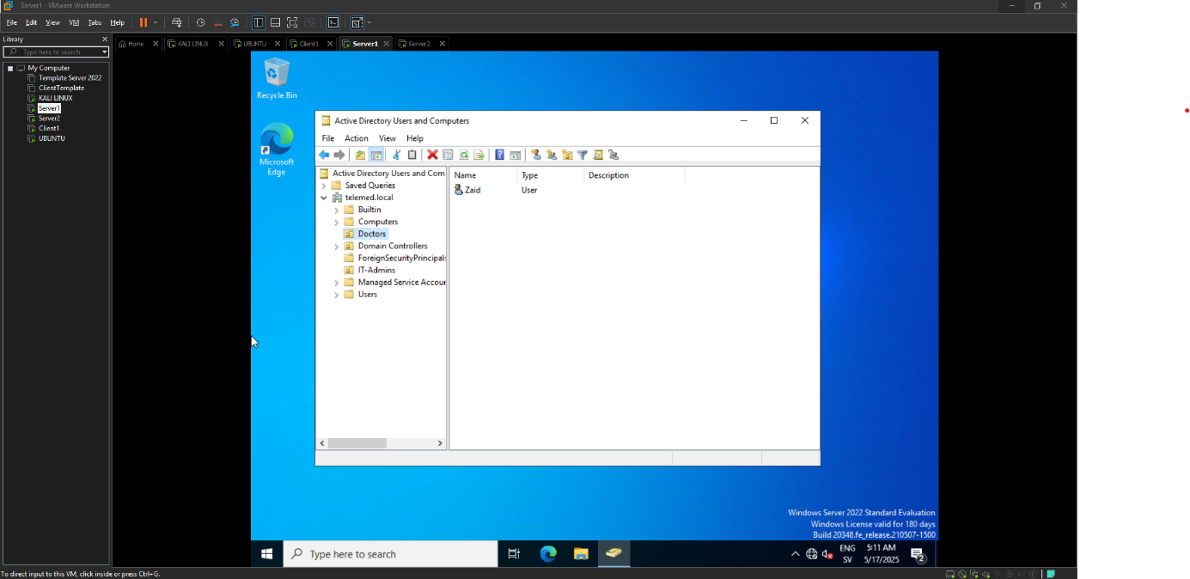

(Al Jaderi, 2025)

**Description:**  
This image shows that the domain name being used is "telemed.local". The image also shows that the user "Zaid" has been placed in the group "doctors" in Active Directory on Server1.

**Purpose:**  
This method confirms that the user account has been applied to a doctor, and specifically that the account has been placed in the correct OU unit for the correct professional role. By structuring these different user accounts into different groups, the risk of unauthorized access to sensitive information is reduced. This is also a clear example of "RBAC". This method also makes administrative work and management easier, as well as simplifying assignment and supporting traceability within the network. It also aligns with GDPR and HIPAA since strict access control is required according to the regulations.

**Part of project step:**  
Domain structure and user creation

**Supports:**  
Linked to point 2.2 (secure user management) and 2.5 (access-based security model).

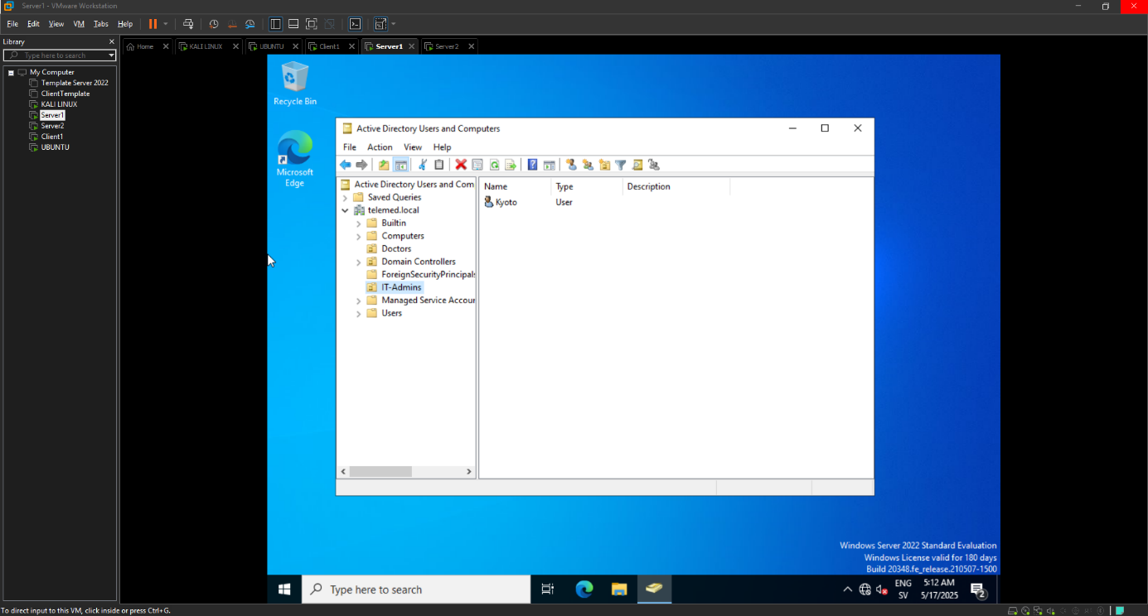

(Al Jaderi, 2025)

**Description:**  
Here you can see that "kyoto" has been placed in IT-admins and in the same domain as telemed.local on Server1.

**Purpose:**  
With this reference, it can be seen that a separate user account has been applied and created for different roles — in this case, IT administrative tasks — and placed in a different group than the doctor. Remember that each OU can have its own policies and permissions, which increases security and creates a clear division of responsibilities.

**Part of project:**  
Domain configuration and user creation

**Used for:**  
To apply different security rules per user group (2.2, 2.5)

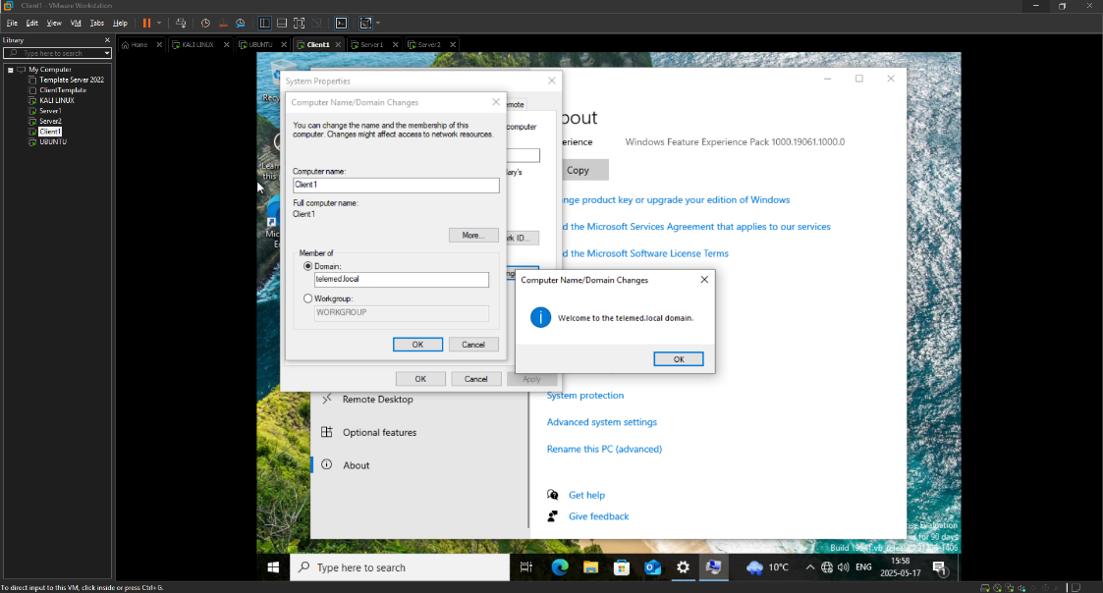

(Al Jaderi, 2025)

**Description:**  
This image shows that connection to the domain via the Windows client has been applied, and the domain it is connected to is telemed.local, which can be seen in the popup window that says “welcome to the telemed.local domain”.

**Purpose:**  
Through this connection, it enables the possibility to control policies and security rules for the users who have access. This also makes it easier to log in and simplifies access management for all IT staff. It creates a stricter and more secure environment.

**Part of project:**  
Domain integration and client setup

**Related to:**  
Access control and centralized management (2.2, 2.5)

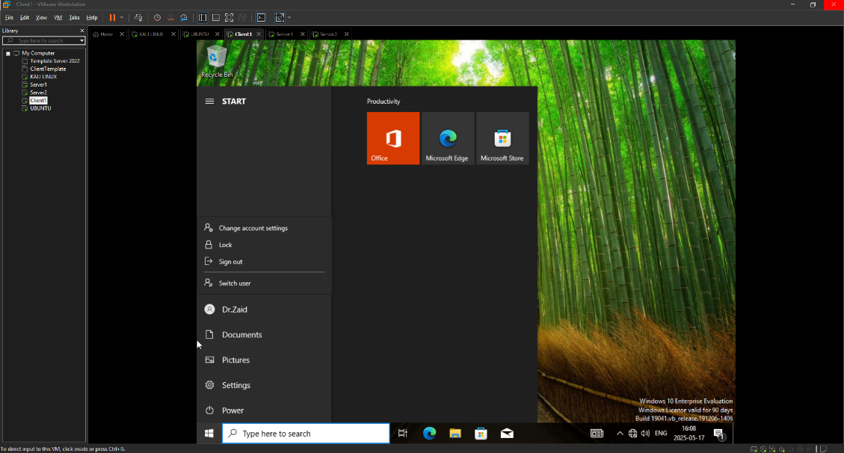

(Al Jaderi, 2025)

**Description:**  
This image shows that a user has previously been created and placed in the OU group "doctors". The image also shows that the domain user Dr.zaid has successfully logged in via the Windows 10 client.

**Purpose:**  
This view shows that access control through Active Directory works and is going according to plan. The image also shows that domain login works and that no issues have occurred, and that the user accounts are active.

**Part of project:**  
Domain-based user login

**Related to:**  
Secure user access and role separation (2.2, 2.5)

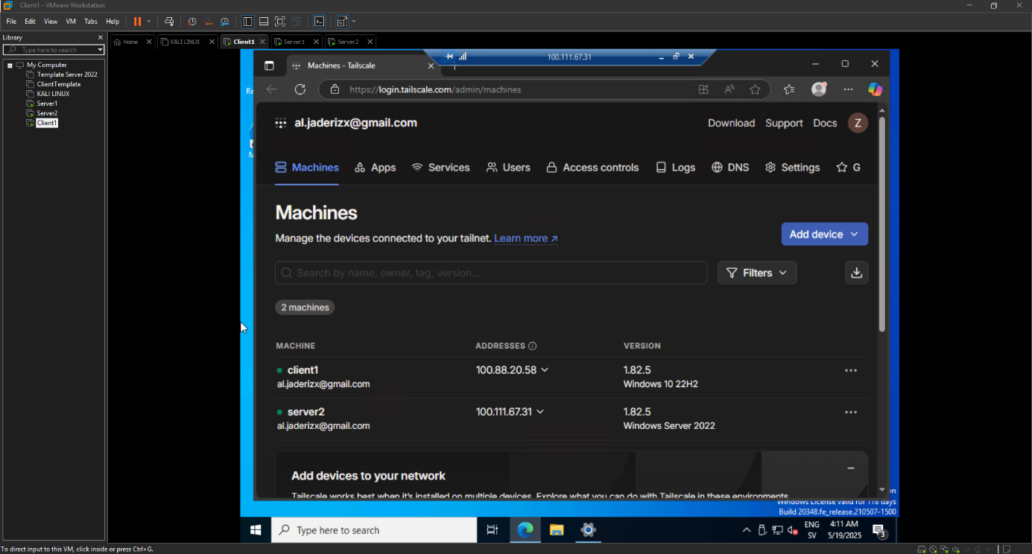

(Al Jaderi, 2025)

**Description:**  
Here we can see the respective IP addresses and how they have been assigned by Tailscale. This image also shows and demonstrates that both Server2 and Client1 have been able to connect to the same Tailscale network. It is also clear that they have received unique IP addresses through Tailscale.

**Purpose:**  
This shows that a VPN connection has been applied and has worked between the server and the client, with the help of Tailscale. This makes it possible for the remote access to be protected and the network between these two machines to be secure.

**Part of project:**  
VPN configuration for remote access

**Used for:**

* Secure VPN connection (Goal 2.1 and 2.2)
* Remote access solution according to NSM's guidelines

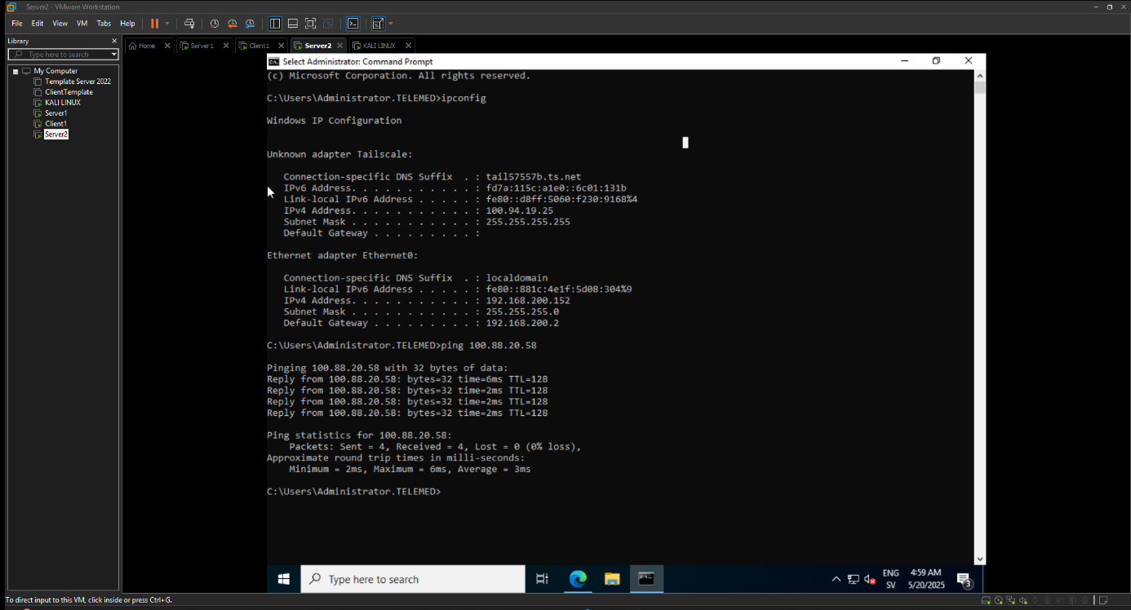

(Al Jaderi, 2025)

**Description:**  
This shows that a successful ping has occurred, through an inbound rule created in Windows Defender Firewall (ICMPv4). This has allowed Server2 to ping Client1 via Tailscale’s VPN address (100.88.20.58). With this shown image, we can see that the VPN tunnel works correctly without any issues.

**Purpose:**  
This shows that communication between the server and the client works over Tailscale’s secure network. It also verifies the connection and availability.

**Part of project:**  
VPN configuration and network verification

**Used for:**

* VPN connection test
* Communication control (2.2, 3)
* Shows encrypted remote communication

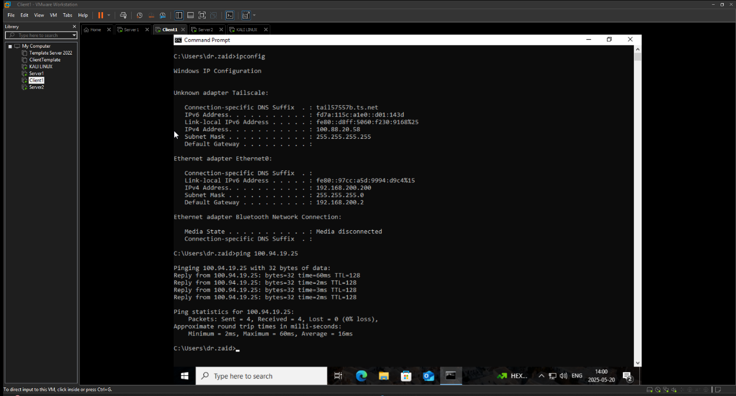

(Al Jaderi, 2025)

**Description:**  
This image shows two-way communication via VPN-Tailscale. It is done by Client1 pinging Server2 using Server2’s Tailscale address, which is shown in the image (100.94.19.25).

**Purpose:**  
This shows that it enables secure access when users and staff work from home. The client shows and confirms that it has a stable and correct VPN connection to the server.

**Part of project:**

VPN functionality and network test

**Used for:**

* Secure remote connection from client to server
* Part of the implementation for home office solution (goal 2.1, 2.2, 2.5)

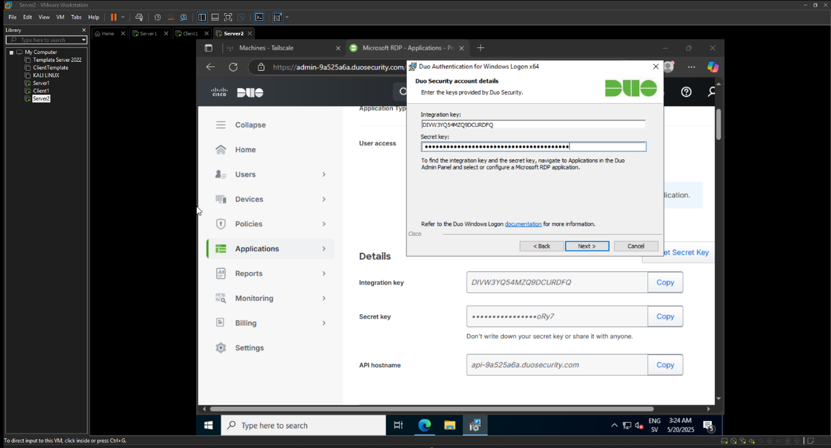

(Al Jaderi, 2025)

**Description:**  
This image shows the input of the integration key, API hostname, and secret key. This is to configure DUO MFA on Server2, which is done from the Duo admin panel. Through the installation guide, an authentication for Windows-based users is created, called “Windows Logon”.

**Purpose:**  
This is to enable the use of Duo’s cloud service for logins via MFA.

**Part of project:**  
MFA implementation on the server

**Used for:**  
Secure authentication for remote login via RDP to Server2

**Part of implementation:**  
Goal 2.3 (Authentication) and 3 (Secure access control)

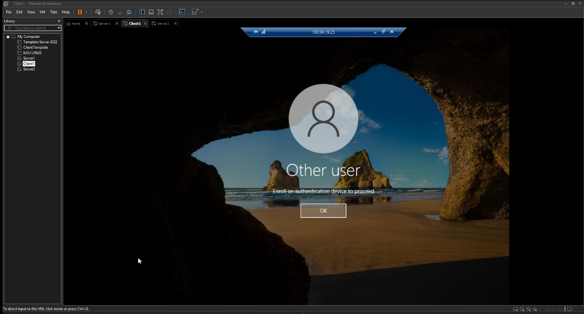

(Al Jaderi, 2025)

**Description:**  
This image is proof that DUO MFA is activated. The image shows that Server2 receives a message when trying to log in that says “enroll an authentication device to proceed”. This can be done because DUO MFA is waiting for the user to connect a verification device.

**Purpose:**  
This demonstrates that no user would be able to log in without first using authentication. This can be done, as in this example, via your mobile device — in other words, “DUO Mobile”.

**Part of project:**  
Verification that MFA is functioning and protecting the system

**Used for:**  
To prevent unauthorized access by requiring multi-factor login

**Part of implementation:**  
Goal 2.3 and 3 (secure authentication and policy control)

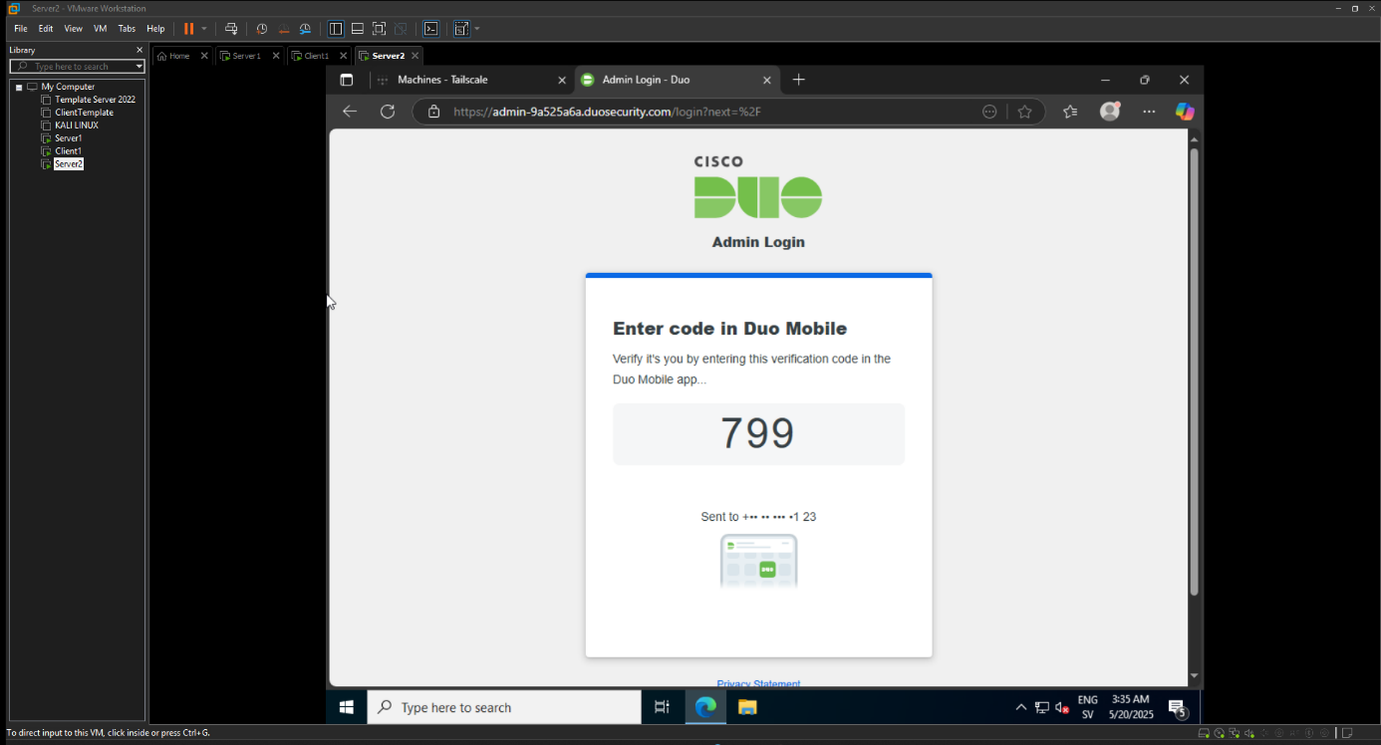

(Al Jaderi, 2025)

**Description:**  
This image shows a real-time identity verification for a login process. The user who wants to log in is required to enter a code from their mobile device via the Duo Mobile app. The code shows “799” to verify and log in.

**Purpose:**  
This is to confirm that the Duo Mobile app works and that it functions with the server, so that DUO can generate time-based codes to the correct mobile device and that it happens correctly without issues, for security.

**Part of project:**  
Completion of MFA login via DUO

**Used for:**  
To ensure that the user actually owns and has access to the registered mobile device

**Part of implementation:**  
Goal 2.3 and 3 – full two-factor authentication

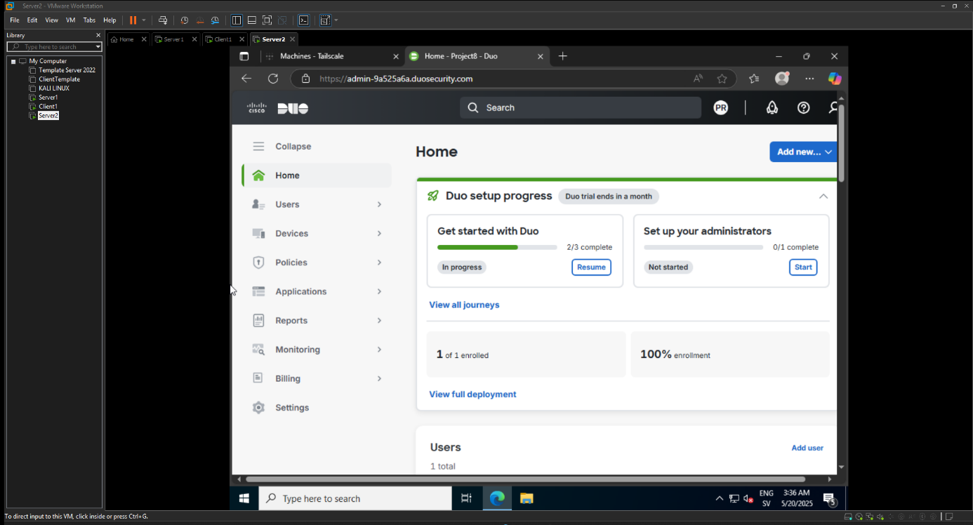

(Al Jaderi, 2025)

**Description:**  
This image simply shows that a user has been registered correctly, and that 100% has been completed.

**Purpose:**  
This shows the integration and a confirmation that it works between the system and the cloud service. It demonstrates that Duo is correctly set up so users can have integration through these systems.

**Part of project:**  
Final verification of the MFA service status

**Used for:**  
Reporting, administration, and security tracking within the system

**Part of implementation:**  
Goal 2.3, 3 (control, governance, and secure user management)

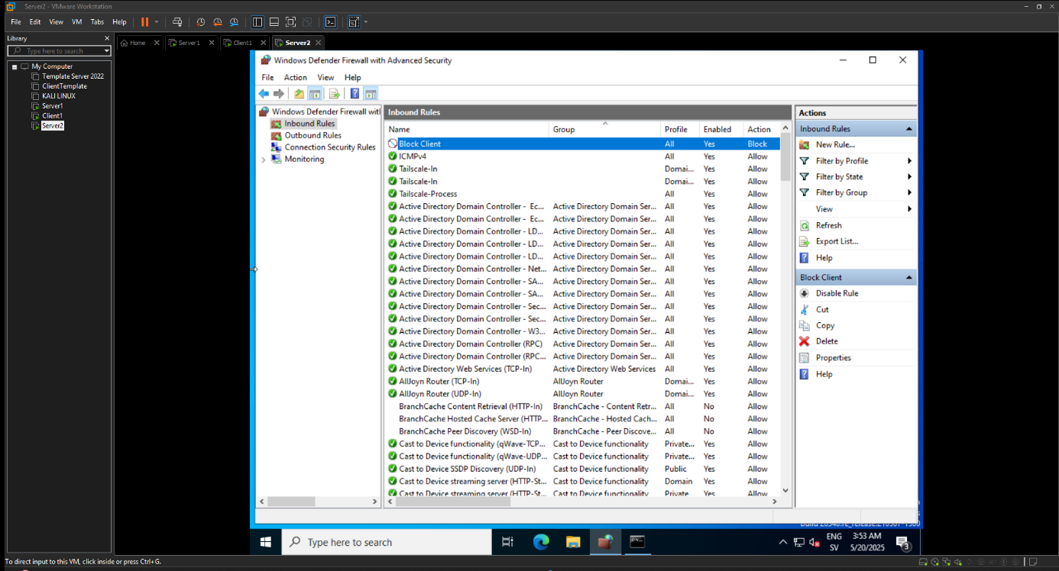

(Al Jaderi, 2025)

**Description:**  
This image shows that a firewall rule has been created. As the image shows, it was created in Windows Defender Firewall, on Server2, where the rule is named “block client”. This rule was created to block incoming traffic from the client, which can be seen in the image as the rule is now active.

**Purpose:**  
This is to demonstrate that a configuration segmentation has taken place between the client and the server, in order to deny unauthorized access coming from the client. This can also be referred to as a “zero-trust network”.

**Part of project:**  
Network segmentation and firewall protection

**Used for:**

* Showing that the server is hardened against incoming connections from clients
* Part of the implementation for secure network architecture (goal 2.3, 2.5)

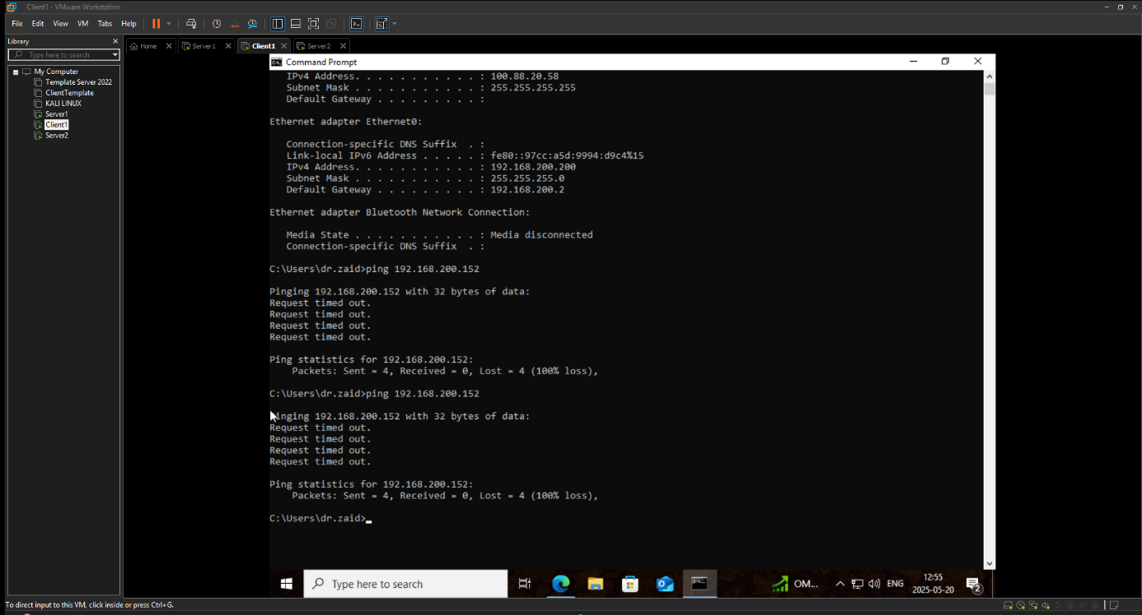

(Al Jaderi, 2025)

**Description:**  
Here we can see that a ping from Client1 has been sent to Server2 to check if it is possible to ping (192.168.200.152). When Client1 tried to ping Server2, it was responded with “request timed out”, which clearly shows that the firewall rule created is working correctly and is now actively blocking.

**Purpose:**  
This is to confirm that all incoming traffic from the client to the server is being blocked, which shows the result of the previous step where the rule was created.

**Part of project:**  
Verification of segmentation policy

**Used for:**

* Demonstrating the effect of network segmentation
* Visualizing protection against unauthorized traffic (goal 2.3, 2.5)

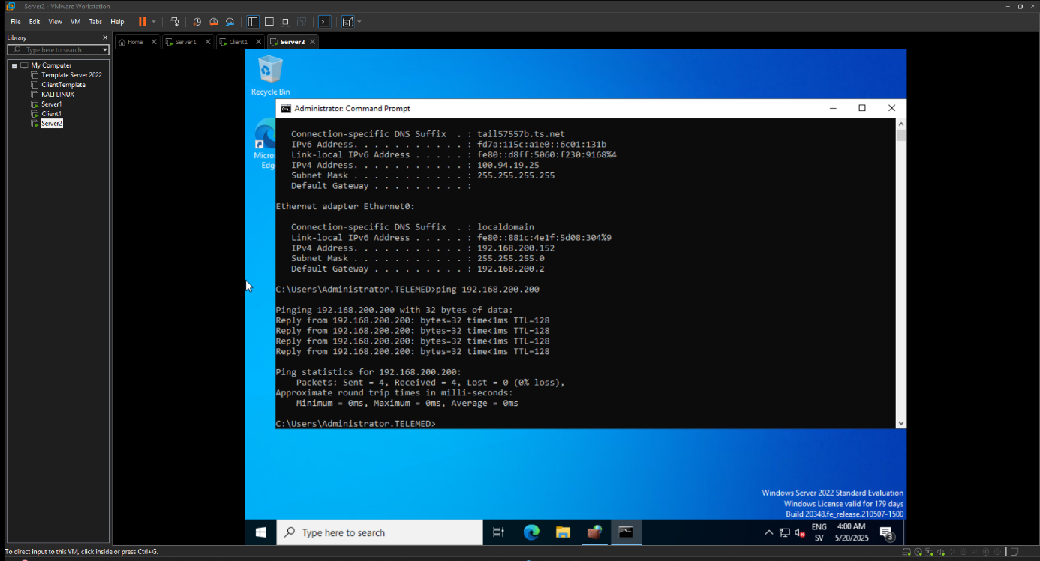

(Al Jaderi, 2025)

**Description:**  
This image shows how Server2 can still ping the client (192.168.200.200) even though the client could not ping Server2. This shows that the one-way blocking of the client has been implemented. Through this block, Server2 can ping the client, but not the other way around — the client cannot ping Server2.

**Purpose:**  
This shows that the server can still perform tasks, such as remote support or log collection. However, the client cannot communicate with the server or initiate the same communication. This also shows that the segmentation is asymmetric.

**Part of project:**  
Verification of controlled access

**Used for:**

* Showing the application of the "least privilege" principle
* Support for secure remote administration (goal 2.2, 2.3)

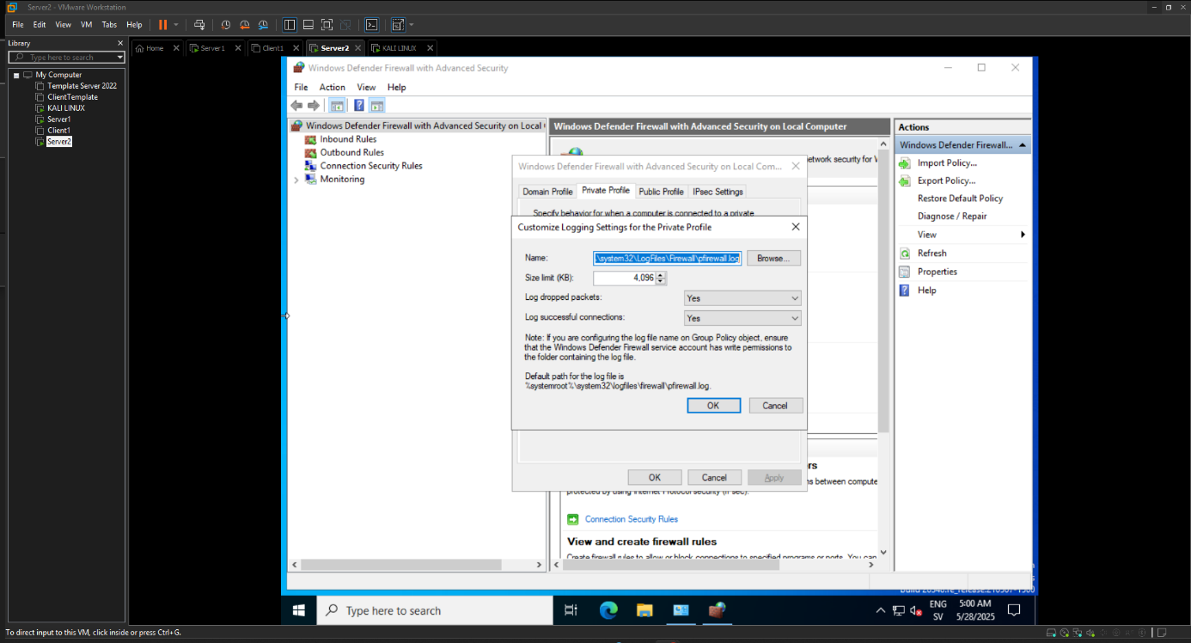

(Al Jaderi, 2025)

**Description:**  
This image shows how logging settings in Windows Defender Firewall have been activated — both allowed and blocked connections have been enabled. Then we can see in the image that the log file is set to be saved at the following path:  
%systemroot%\system32\LogFiles\Firewall\pfirewall.log.

**Purpose:**  
This is to be able to save traffic logs and also have security monitoring of what is happening. This is very important to use, as it is part of being able to trace a potential attack or other unusual activities.

**Part of project:**  
IDS (Intrusion Detection System) and log management

**Used for:**

* Enabling review of blocked attacks (e.g., from Kali Linux)
* Monitoring network attempts against VPN-protected servers
* Verifying segmentation and firewall rules

**Part of implementation:**  
Goal 2.4 (Network Monitoring), 3 (Security Logging)

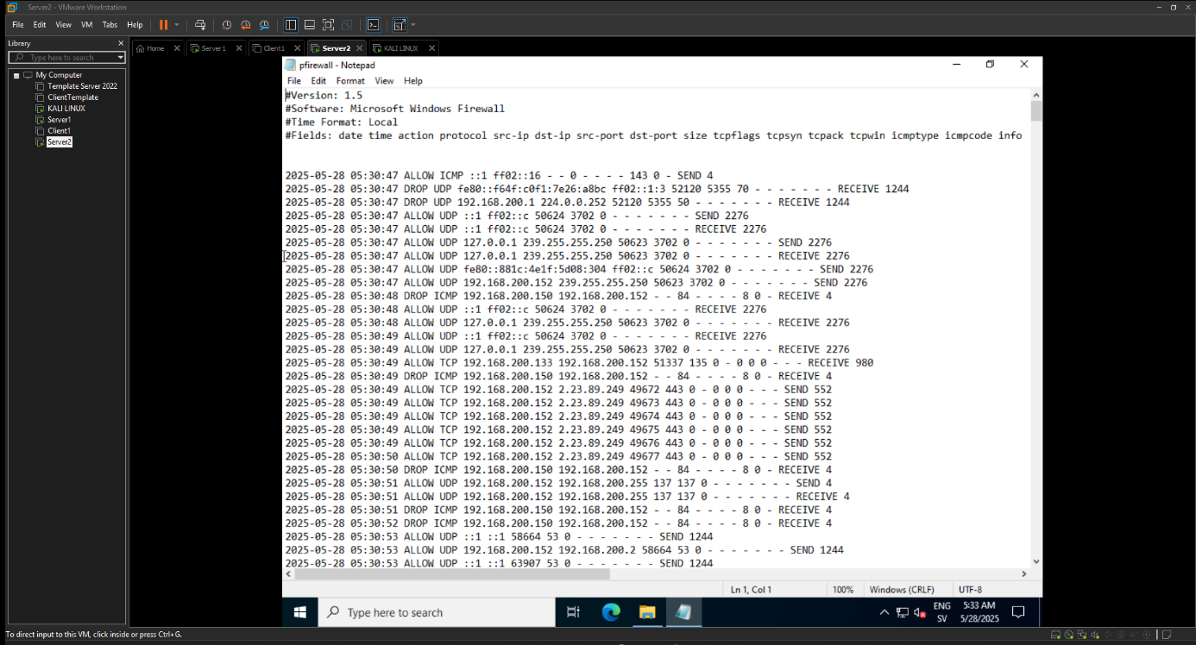

(Al Jaderi, 2025)

**Description:**  
This image shows that Server2 is inside the pfirewall.log to view the contents and the activity that has occurred there. The image also shows that the log contains detailed entries for both blocked traffic attempts and allowed ones. For example, we can see that from the Kali Linux client (192.168.200.1xx) directed at the server, there are multiple dropped ICMP entries, which confirms that several attack attempts or unwanted network attempts have been stopped.

**Purpose:**  
This is to provide a visualization of an access attempt, in this case from (Kali), which is considered a potential attacker. It shows that when Kali tries to attack, it is logged and blocked by the firewall, which is proof that the security monitoring is functioning correctly.

**Part of project:**  
Intrusion detection and firewall verification

**Used for:**

* Documenting that attempts to connect from unauthorized devices are being blocked
* Proving that the previously configured firewall rule (e.g., Block Client) logs correctly
* Basis for report and security analysis

**Part of implementation:**  
Goal 2.4 (Intrusion Detection), 2.5 (Firewall & Segmentation)

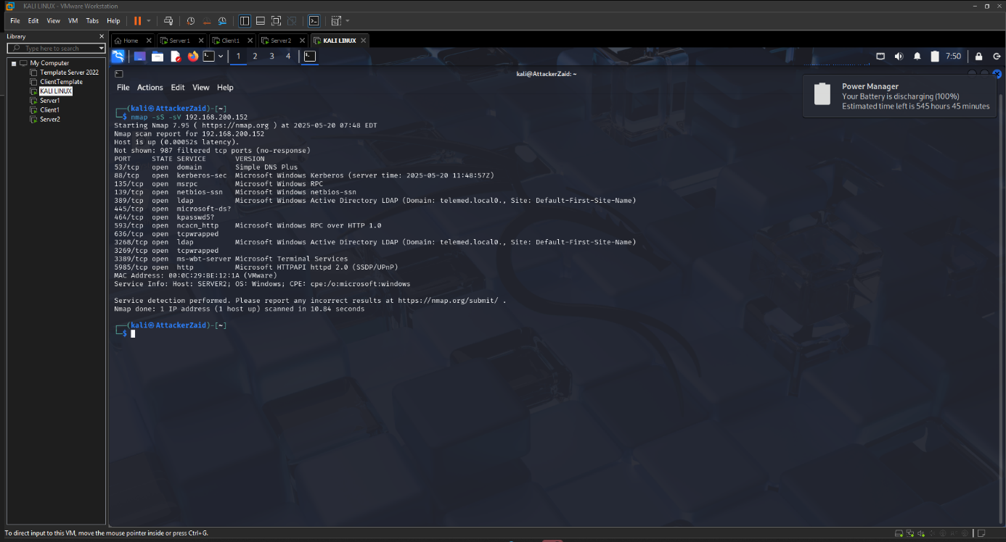

(Al Jaderi, 2025)

**Description:**  
This image shows that a command via Kali Linux has been entered. The command is nmap -sS -sV, which was executed from Kali to Server2’s IP address (192.168.200.152). This is done to scan and identify various services or open ports. The image shows that through the scan, the following can be seen: ports like 53 (DNS), 135 (MSRPC), 139 (NetBIOS), 445 (SMB), 3389 (RDP), and also services such as Microsoft Active Directory LDAP, Kerberos, HTTP, among others.

**Purpose:**  
This method demonstrates and simulates an attacker attempt. It also shows that Kali can perform a scan called “port scanning” on the network to discover vulnerable services that may exist and be a potential risk on Server2.

**Part of project:**  
Risk analysis, penetration testing, and vulnerability identification

**Used for:**

* Proving that IDS/firewall needs to be active to detect and log this type of scanning
* Showing which services are exposed and could be exploited
* Matching against logging in pfirewall.log (e.g., DROP ICMP, DROP TCP)

**Part of implementation:**  
Goal 2.3 (Threat Simulation), 2.4 (Monitoring), 2.5 (Segmentation & Defense)

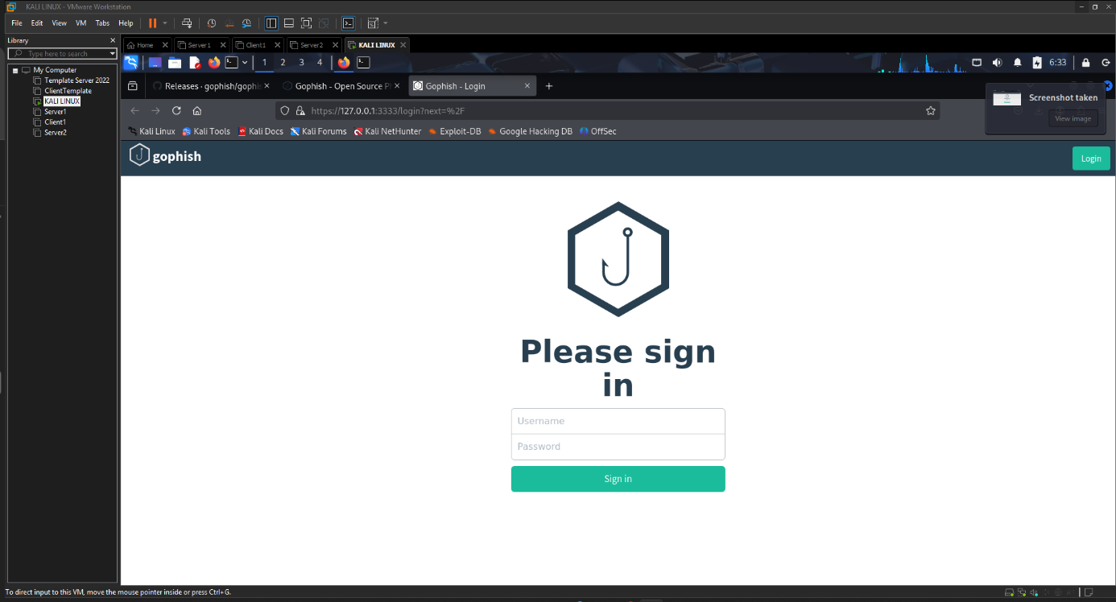

(Al Jaderi, 2025)

**Description:**  
This image shows that the user is prompted to log in with both a password and a username. This is also how the login page for Gophish looks. The URL also shows: <https://127.0.0.1:3333/login>

**Purpose:**  
This proves that the installation of Gophish has been carried out correctly and that it is accessible locally on the Kali Linux machine.

**Part of project:**  
Starting point for phishing simulations via Gophish

**Used for:**  
Administrative login in Gophish to create templates and campaigns

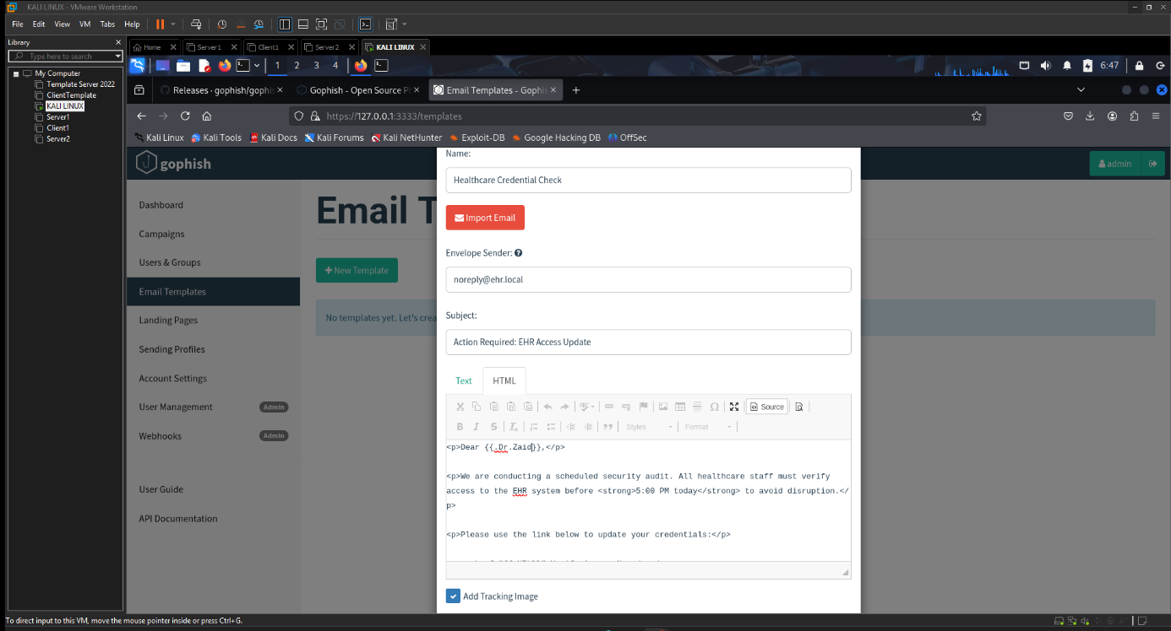

(Al Jaderi, 2025)

**Description:**  
This shows that a template is designed to trick someone — it is a fake message formatted as a security notice with a link for “credential harvesting”. It also shows that you can create an email template in Gophish for such purposes.

**Purpose:**  
This is to show how a phishing template can be designed and created to trick different recipients or company users into giving up information.

**Part of project:**  
Create realistic phishing content to test awareness and protection

**Used for:**  
Design of phishing emails for healthcare staff (goal 2.3 and 2.5)

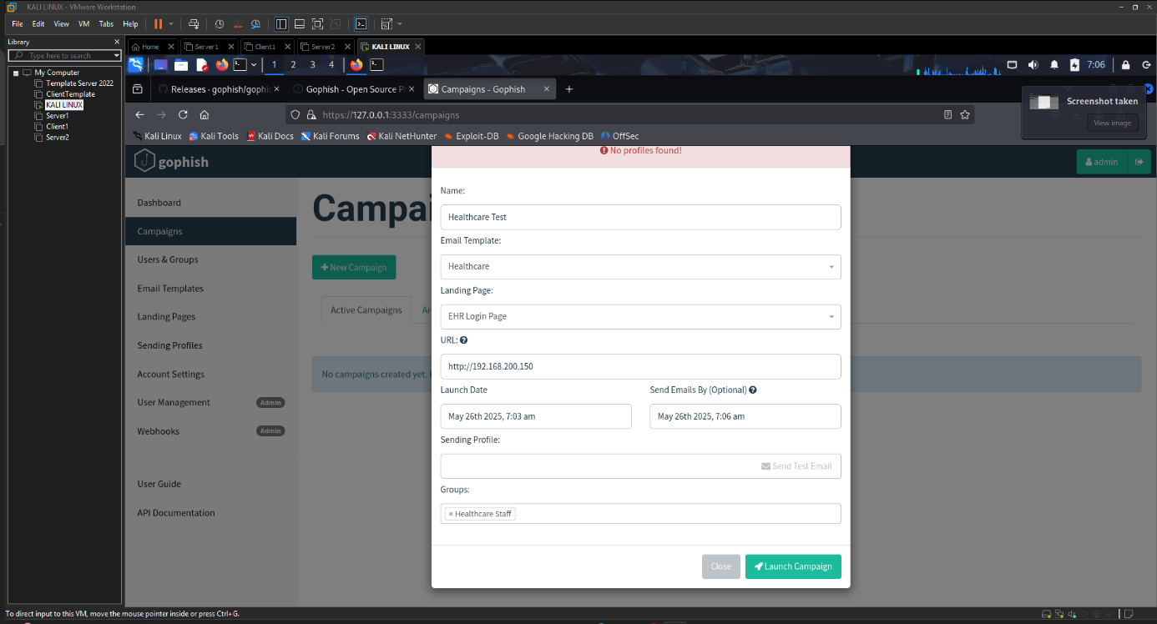

(Al Jaderi, 2025)

**Description:**  
This image shows how, through Gophish, you can select the template you want, target a specific audience or schedule for a phishing campaign, and how it is configured.

**Purpose:**  
This is to show how to schedule an email campaign to carry out a phishing attack.

**Part of project:**  
Field test for cybersecurity capability within the organization

**Used for:**  
Campaign simulation with user data and analysis of click/login behavior

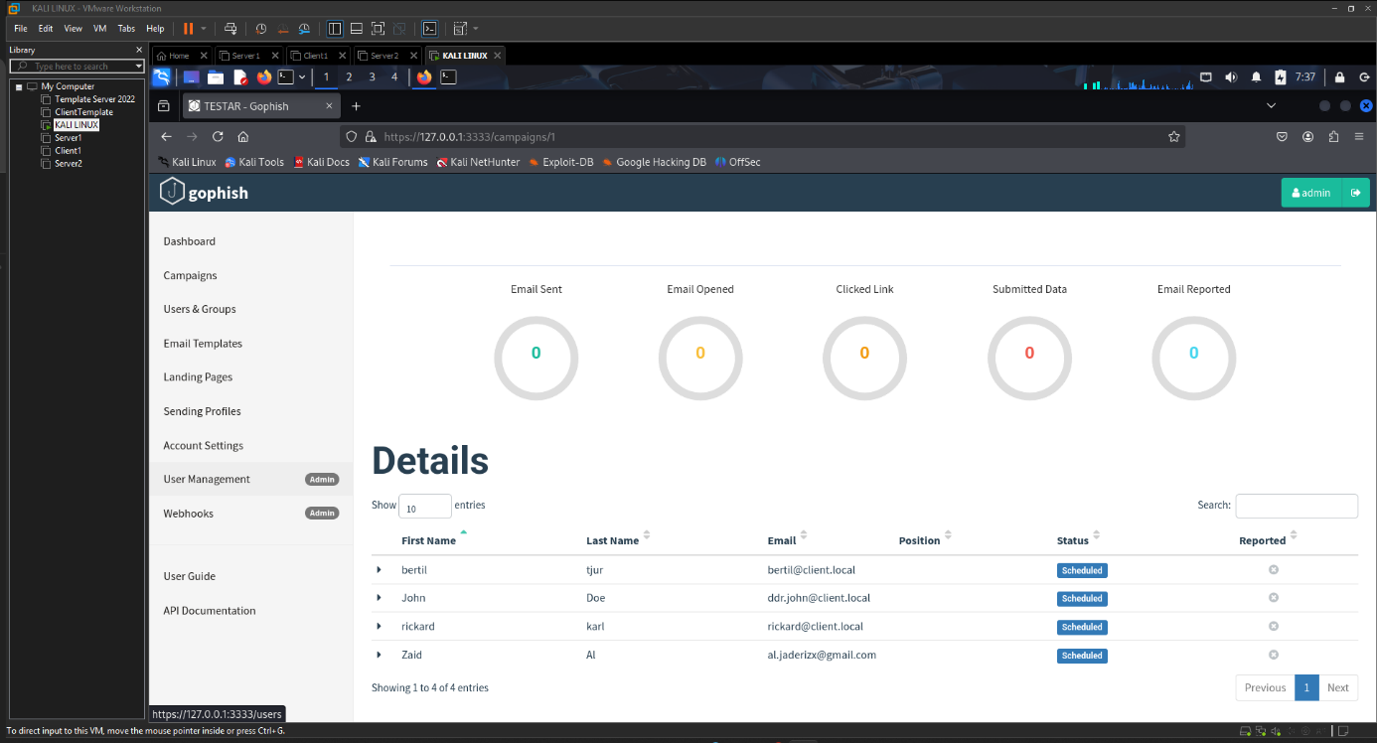

(Al Jaderi, 2025)

**Description:**  
This image shows how the Gophish panel has four users with the status “scheduled”. This indicates that the email campaign is ready to be sent to the selected recipients at the chosen time.

**Purpose:**  
This is to confirm that the users intended to be included in the campaign have been verified and identified in this campaign.

**Part of project:**  
Final phase of phishing test, before sending

**Used for:**  
Documentation of which users are included in the phishing test

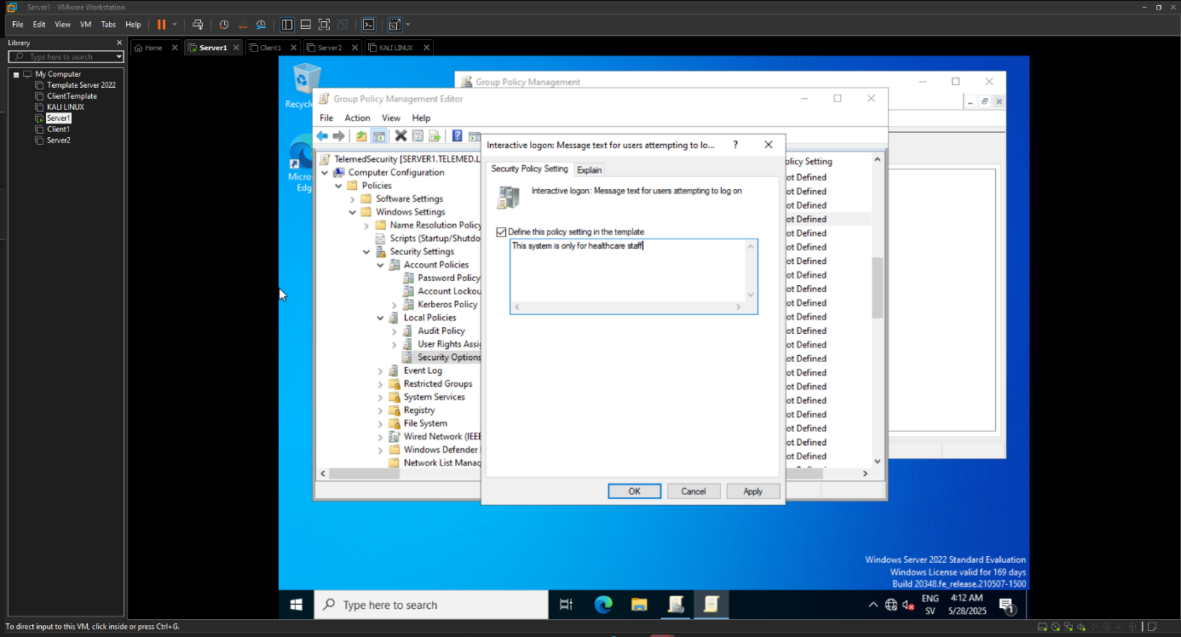

(Al Jaderi, 2025)

**Description:**  
This image shows a security policy created under "Group Policy Management". The setting displays a text that says “message text for users attempting to log in”. Such a policy is created or used as a warning message for users who are about to log in to a computer or server. This message specifies that it is only for healthcare staff: “this system is only for healthcare staff”. This is meant to deter unauthorized users from logging in, and also complies with strict regulations such as “GDPR, HIPAA”.

**Purpose:**  
This is to inform users during login that the system is intended only for healthcare staff and no one else. This creates a security policy.

**Part of project:**  
Policy communication during authentication (GPO – security measure)

**Used for:**

* Making users aware of access conditions
* Reducing unauthorized access
* Compliance with regulatory requirements (goal 2.2, 2.4)

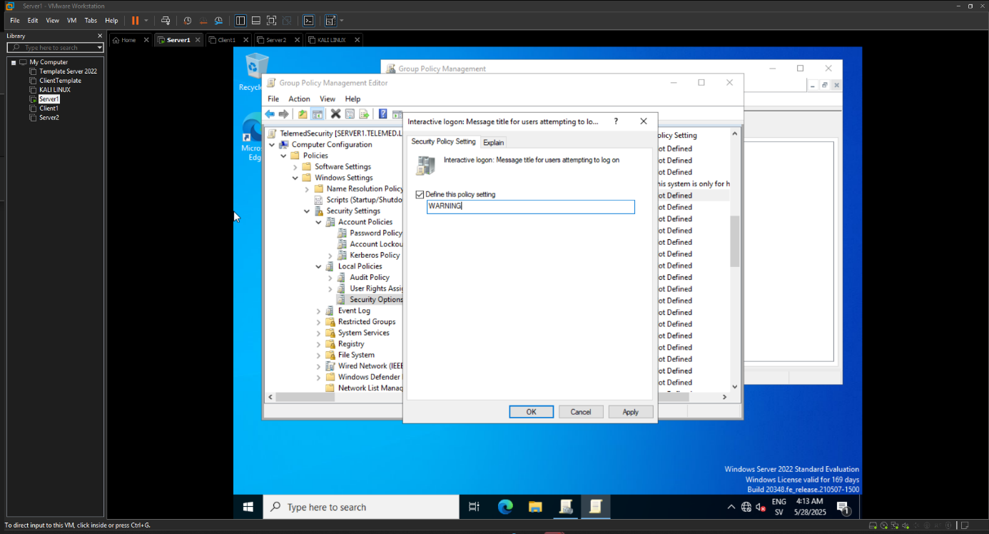

(Al Jaderi, 2025)

**Description:**  
This image shows that the title says “WARNING”. This is displayed as a heading when someone tries to log in, to catch the user's attention. The purpose of this warning is to clearly indicate that this system is restricted and that the information that follows is important. This strengthens both user awareness and aligns with the security policy.

**Purpose:**  
This is to provide a visual warning and an additional alert that this system is protected and restricted to a limited number of users.

**Part of project:**  
Authentication and secure message handling (GPO – security measure)

**Used for:**

* Displaying a clear warning before login
* Emphasizing that violations may have consequences (goal 2.2)

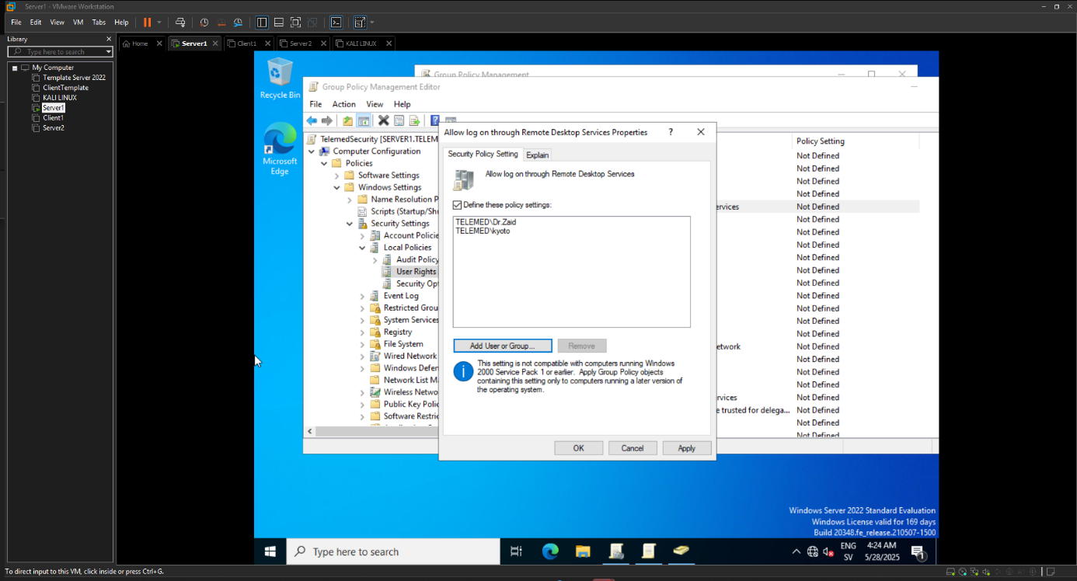

(Al Jaderi, 2025)

**Description:**  
This image shows that via GPO, both “telemed\kyoto” and “telemed\dr.zaid”, who are users, have been granted permission and rights to use remote access to the system via RDP. This shows that only these two have access and permission for remote access.

**Purpose:**  
This is to grant remote login rights to the specific users intended to use it, while restricting all others from logging in via RDP.

**Part of project:**  
Remote access control via GPO

**Used for:**

* Managing access to the system via RDP
* Ensuring that only authorized users are granted remote access (goal 2.1, 2.5)

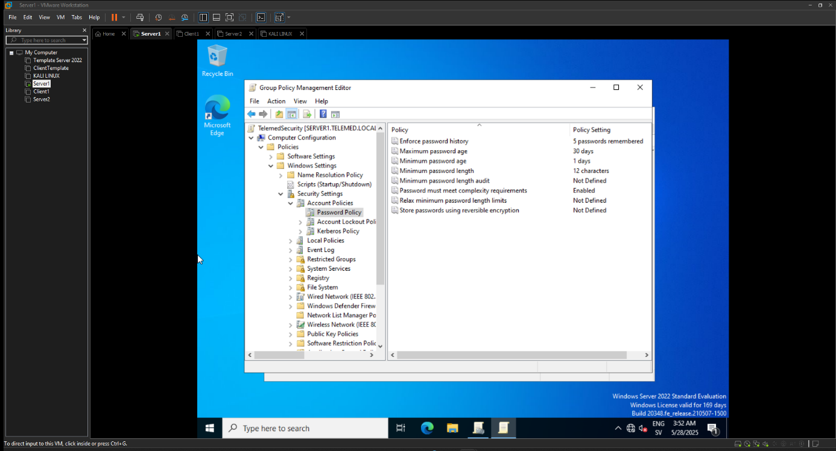

(Al Jaderi, 2025)

**Description:**  
This image shows the creation of a required "length" for passwords. The length that has been set is 12 characters, which makes the passwords more complex. This was done through GPO settings for password policy.

**Purpose:**  
The purpose of this is to force users to have complex and strong passwords, which minimizes the risk of attackers targeting passwords to gain access to information.

**Part of project:**  
Basic authentication security

**Used for:**

* Preventing weak passwords
* Strengthening account security in the environment (goal 2.4)

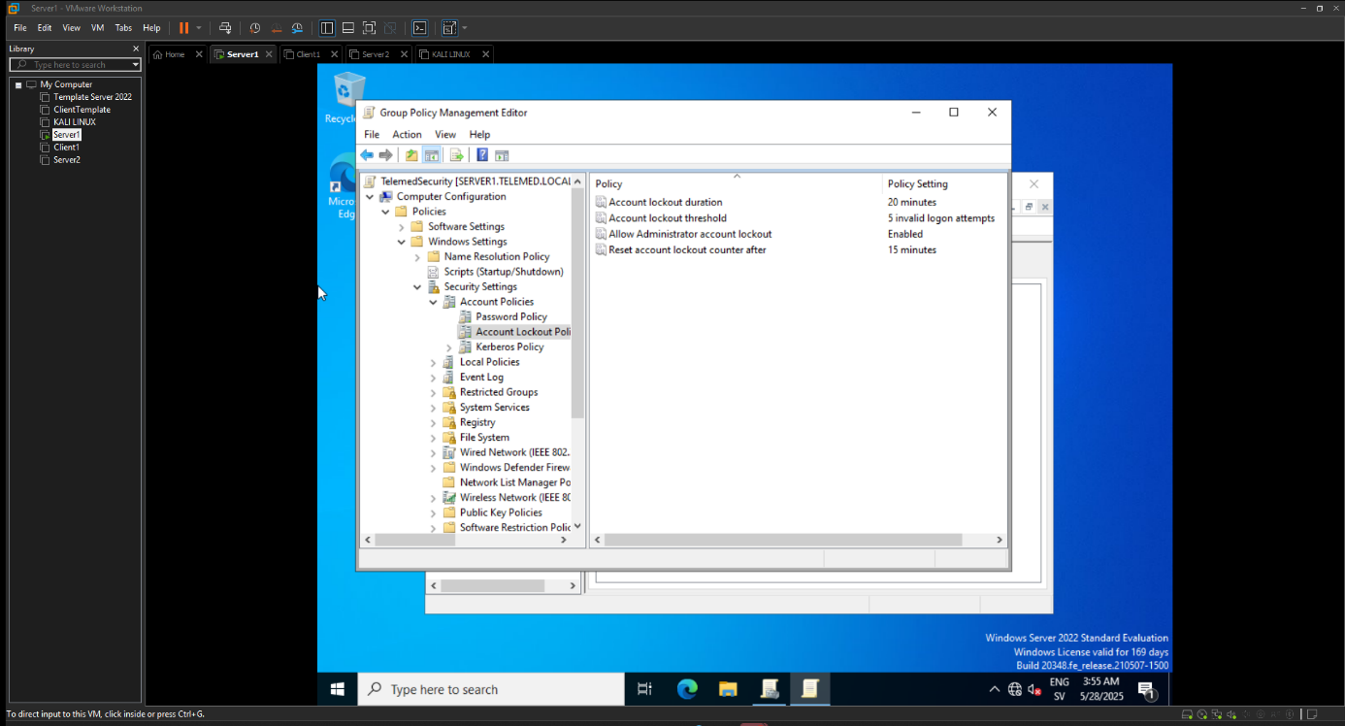

(Al Jaderi, 2025)

**Description:**  
This image shows how a GPO setting has been applied so that if someone tries to log in and fails, it will lead to an account lockout, and the count resets after 15 minutes.

**Purpose:**  
This protects against brute-force attacks. It also protects against unauthorized users trying to gain access by guessing passwords. This shows yet another security policy that creates a safer environment in the workplace.

**Part of project:**  
Secure authentication policy and incident minimization

**Used for:**

* Limiting the number of login attempts
* Delaying automated attacks against accounts (goal 2.4)

**4. Summary and Conclusion**

The idea behind this project was to focus on how to secure the telemedicine IT environment. This was done by researching and identifying the different risks that can arise and then implementing it in practice by creating and setting up several different security measures.

This was created in practice through implementation in a virtual lab environment. The lab environment consisted of two Windows servers, a Kali Linux machine, and also a domain connection via the Windows client. Through this process and setup, the goal was to create security and protection within remote work that takes place in healthcare, especially when it comes to sensitive patient data, user awareness, and remote access.

Through several methods, the results showed multiple vulnerabilities, such as the lack of multi-factor authentication, some RDP ports being open, and also insufficient and weak network segmentation. This showed that it can lead to serious risks and consequences.

But this was addressed through different methods, and it was done successfully. By configuring Tailscale VPN, installing Duo MFA, and creating various firewall rules, access could be limited between different devices and create a safer environment. Then, by letting users connect via the domain and creating login warnings and different password policies, the network could be more organized and safer to use.

Through a testing method called “threat simulation,” the Nmap command was used via Kali Linux to discover different open services. Furthermore, Gophish was used to simulate various phishing attacks that can happen and how they can look. Testing of logs and monitoring was done via Windows’ own built-in tools, and the results showed that the system blocked and recorded the unauthorized traffic, which proved that the test was successful.

All testing and methods were documented with screenshots to demonstrate and confirm that the security improvements made were working correctly and successfully. This project also clearly showed healthcare companies how they can protect their remote work, but also protect patient information and comply with the rules and laws within GDPR and HIPAA. Not only that, the project also shows that companies can use cost-effective tools, which makes it easier for smaller companies that have fewer resources.

With that said, it can be summarized that remote access requires strong solutions, such as MFA or VPN, but also that employees should be trained, as it is crucial to prevent human errors in healthcare companies. The results also show that small details and technical measures need to be created and implemented more structurally to significantly reduce cybersecurity risks in the company.

**References:**

**Al Jaderi, Z. (2025).** Cybersecurity illustration generated using ChatGPT. Unpublished image.

**Al Jaderi, Z. (2025).** Own screenshots captured in lab environment for cybersecurity project. Unpublished material.

**American Medical Association. (2023).** 74% of physicians work in practices that offer telehealth. [online] AMA. Available at: <https://www.ama-assn.org/practice-management/digital-health/74-physicians-work-practices-offer-telehealth> [Accessed 9 Jun. 2025].

**Cetrom. (2025).** The importance of mitigating human error in cybersecurity. [online] Available at: <https://www.cetrom.net/resources/blog/importance-of-mitigating-human-error-in-cybersecurity> [Accessed 13 Jun. 2025].

**Cisco. (2025).** What is Duo? Available at: <https://www.cisco.com/site/us/en/learn/topics/security/what-is-duo.html> (Accessed: 9 June 2025).

**Fidelis Security. (2025).** Healthcare data breaches: Top Causes of Data Breaches in Healthcare: Guide to Preventing Them [online] Available at: <https://fidelissecurity.com/cybersecurity-101/data-protection/healthcare-data-breaches/> [Accessed 9 Jun. 2025].

**HIPAA Journal (2024)** Healthcare Data Breach Statistics. [online] Available at: <https://www.hipaajournal.com/healthcare-data-breach-statistics> [Accessed 2 Jun. 2025].

**IBM (2024)** Cost of a Data Breach: Healthcare Industry. [online] Available at: <https://www.ibm.com/think/insights/cost-of-a-data-breach-healthcare-industry> [Accessed 2 Jun. 2025].

**NHS Digital. (2023).** Network segmentation - An introduction for health and care organisations [online] Available at: <https://digital.nhs.uk/cyber-and-data-security/guidance-and-assurance/network-segmentation/introduction> [Accessed 9 Jun. 2025].

**Securiti. (2025).** GDPR vs HIPAA: What are the Differences? [online] Available at: <https://securiti.ai/gdpr-vs-hipaa/> [Accessed 9 Jun 2025].

**Tailscale. (2025).** What is Tailscale? [online] Available at: <https://tailscale.com/kb/1151/what-is-tailscale> [Accessed 9 Jun. 2025].